**MECHANICSBURG AREA**

**SCHOOL DISTRICT THE WILDCAT FOUNDATION**

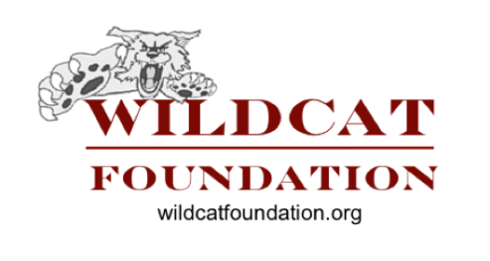



**PARTNERS IN**

**EDUCATION**

Wildcat Foundation Employee Pledge Form

Established in 1998, the mission of the Wildcat Foundation is *to strengthen the educational, cultural, wellness, and athletic programs of the Mechanicsburg Area School District*.

By completing the information below, you may make a tax deductible contribution to the Foundation, payable through payroll deduction. Thank you for your support of the Wildcat Foundation!

**Name: Building:**

# YES! I wish to contribute to the WILDCAT FOUNDATION

*(Please check one)*

* Payroll Deduction

My pledge per pay is: $5 $10 $15 $20

$25 $30 $35 Other

Number of Years: 1 2 3 4 5

My total contribution is $

* Membership (deducted over 1 or 2 pays)

$30 Steel

$60 Maroon

$100 Wildcat

$ Other

Pay Date: Amount:

Pay Date: Amount:

**$1,000 Club**

We invite you to join the MASD **$1,000 Club** by contributing $10 over

100 pays

*(approximately 4 years).*

**To join the $1,000 Club, simply**

**check this box, and sign below.**

**Thank you!**



**Signature: Date: ________________**

**The Wildcat Foundation**

500 S. Broad St.* Mechanicsburg, PA 17055 * 717-691-4505

www.wildcatfoundation.org